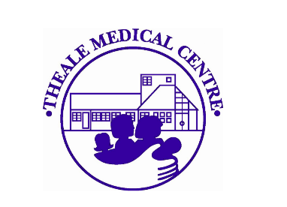

February 2026

Theale Medical Centre
February 2026 Newsletter

It is with sadness that we announce that Dr Rock has made the decision to retire from Theale Medical Centre to spend more time with her family and friends. She has recently been joined by three new partners who will continue to manage the surgery once she has stepped down.
Dr Rock joined the medical centre 29 years ago and will leave the practice at the end of March.
She would like to say a big thank you to all the colleagues that she has worked with.
“I feel extremely privileged to have worked with such an amazing team at TMC. Every person in the practice plays a vital supportive role, making it possible for us to provide medical care to our community. The dedicated clinical team are supported by fantastic administrative, secretarial, reception and dispensary staff. It has been an honour to work with you all.
I would like to also thank the PPG who sit beside us in supporting Theale, Calcot and the surrounding villages.”
Dr Rocks patients will be looked after by the existing team which continues to expand.
She will be greatly missed by patients and staff but all of us are extremely grateful for her hard work and dedication over the last 3 decades.
We wish her a long and happy retirement.

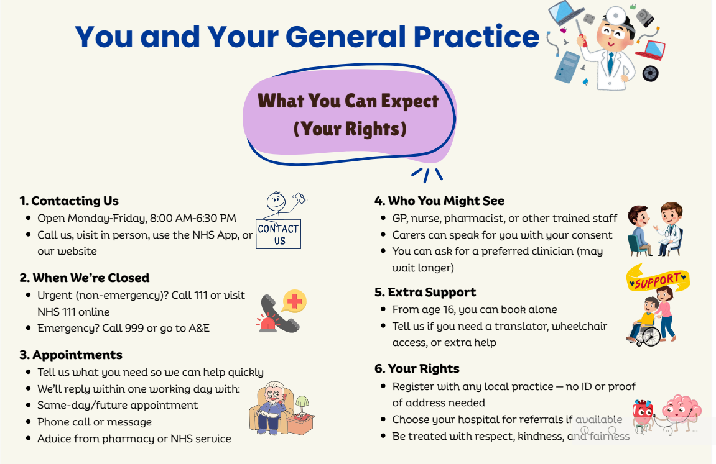



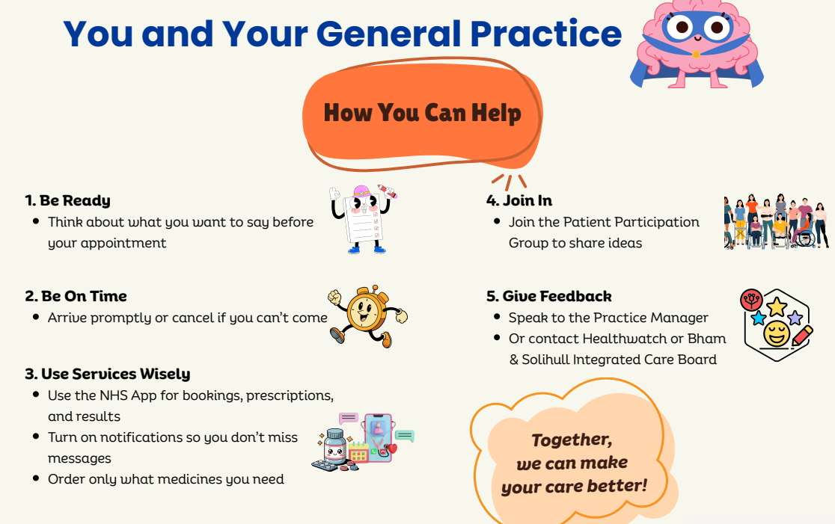

Community Connectors- West Berkshire

Community Connectors (CCs) work within the Mental Health Integrated Community Service (MHICS) under the Berkshire Healthcare NHS Foundation Trust to support anyone experiencing significant mental health issues. They have expert knowledge of the local areas Reading, West Berkshire and Wokingham and can work with clients to access the local support that they need right now.

Who is this service for?

Anyone aged 18+ who is experiencing significant mental health problems, along with life events or circumstances that are impacting their wellbeing e.g. social isolation, financial worries or housing issues.

Main Areas of Support:

- Engagement with Community Groups
- Link with Debt & Financial Support
- Connection with Housing Support
- Link with Drug & Alcohol Support
- Referral to Other Mental Health Professionals

How to Access

Clients can request a MHICS Team referral directly from their GP. The GP will be able to discuss this with them and help with their next steps.

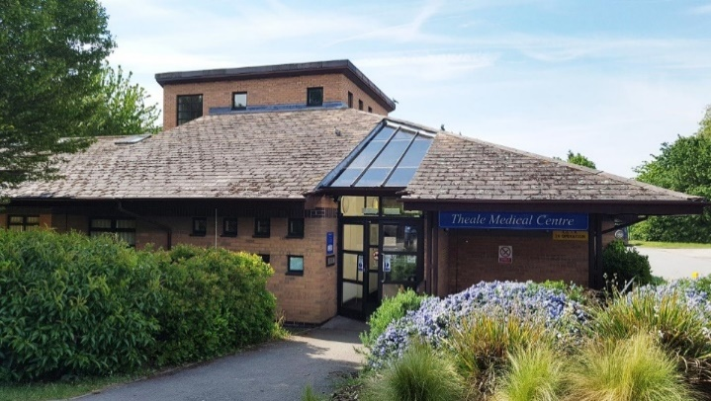
Telephone: 0118 930 3081

General Enquiry Email: bobicb-bw.tmc@nhs.net

Dispensary Email: bobicb-bw.tmcdispensary@nhs.net

Englefield Road, Theale, Reading RG7 5AS

