

October 2025

Theale Medical Centre
October 2025 Newsletter

Flu and COVID
Eligibility
The announced and authorised cohorts eligible for a COVID-19 vaccine in Autumn Winter 2025/26 are:
- residents in a care home for older adults
- all adults aged 75 years and over
- persons aged 6 months and over who are immunosuppressed

New Triage System

We are always looking for ways to improve your access to GP appointments, as demand continues to rise. We are aware of the increasing wait times for routine GP appointments and have listened to your concerns. Following research, we have found an effective solution that will change the way you access our services.

All requests for GP appointments and queries (routine and urgent) will be reviewed by our triage doctor, on the same day, and an appointment will be offered as clinically appropriate. We want to make sure patients are getting the advice and access they need in a timely manner, in line with their clinical needs.

You should no longer telephone the practice to book a GP appointment. Bookings will be replaced with a new, quick and simple online triage form on our website. This can be accessed through our website between 07:30am – 4 pm, Monday to Friday. If you have an urgent medical need after 4pm, please call the surgery.

This system will be easily accessible for most patients; for those that don’t have access to the internet please call our reception team who will be able to assist you by completing the online request form for you. You are welcome to come to the surgery and speak to them in person, should you prefer.

Once the GP has triaged your request, the outcome may be:
- An urgent appointment that day with the appropriate clinician (GP / Paramedic / Nurse Practitioner)
- An urgent GP appointment
- A routine GP appointment
- Referral for relevant tests
- A nurse appointment
- A reply via your chosen contact method for queries that do not need an appointment
- Passed on to our clinical pharmacist team for relevant medication queries
- Passed on to our admin team, such as medical secretaries, for relevant queries
- A referral to our social prescriber
- Signposted to other providers, such as community pharmacy, physiotherapy, minor injuries, or 111.

Please note, there is no change to the booking of nurse or health care assistant appointments for the time being – these appointments can be arranged by phoning the surgery, as usual.





Stroke warning signs

F.A.S.T is the acronym that refers to the urgent action needed if you see signs of a stroke.

What to do if you suspect a stroke
Check for the F.A.S.T. signs
  - Face: Is one side of their face drooping or fallen? Can they smile properly?
  - Arms: Can they raise both arms and keep them raised?
  - Speech: Is their speech slurred or unusual?
  - Time: If you see any of these signs, it's time to call the emergency number immediately.
Call for help
  - Even if the symptoms are mild or disappear, call 999.
  - Time is critical, as prompt treatment can significantly improve the chances of recovery and reduce the severity of long-term effects.

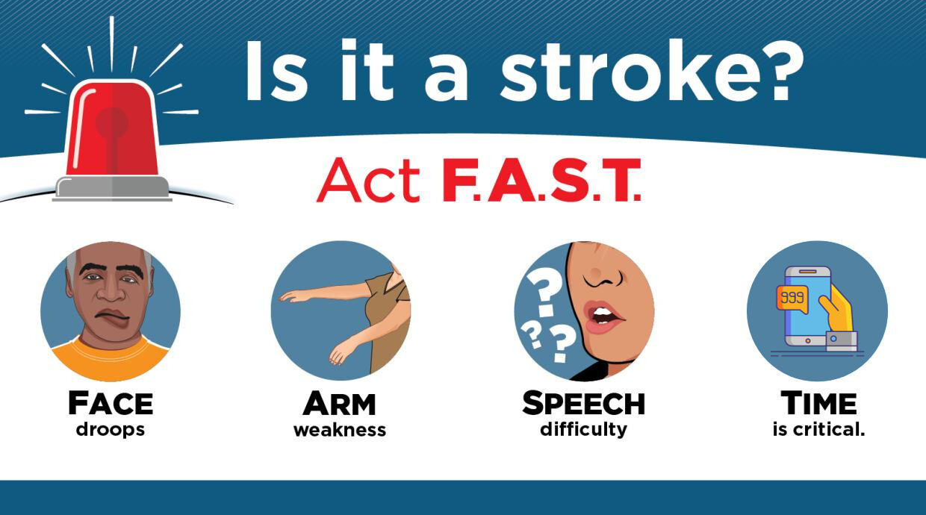
Heart attack warning signs

Symptoms vary between individuals and may occur with or without chest pain. If you or someone you know experiences these symptoms, call 999 immediately, as prompt treatment is critical for better outcomes.
Common Warning Signs
- Chest pain or discomfort: This is the most common symptom and can feel like pressure, tightness, squeezing, or aching in the centre or left side of the chest.
- Pain in other body parts: The discomfort can spread to one or both arms (especially the left arm), the neck, jaw, back, or stomach.
- Shortness of breath: Difficulty breathing may occur with or without chest discomfort.
- Cold sweats: Breaking out in a cold sweat with clammy skin can be a sign of a heart attack.
- Nausea or vomiting: Feeling sick to your stomach or throwing up are also potential symptoms.
- Light-headedness or dizziness: A feeling of dizziness or light-headedness can occur.
- Anxiety: An overwhelming feeling of anxiety, similar to a panic attack, can also be a warning sign.


Telephone: 0118 930 3081

General Enquiry Email: bobicb-bw.tmc@nhs.net

Dispensary Email: bobicb-bw.tmcdispensary@nhs.net

Englefield Road, Theale, Reading RG7 5AS



